**MINOR PROJECT REPORT**

BIPIN TRIPATHI KUMAON INSTITUTE OF TECHNOLOGY (263653)

DWARAHAT, UTTARAKHAND

PROJECT REPORT ON

“DIGITAL DATA TRANSMISSION USING **LIGHT FIDELITY**”



SUBMITTED TO: submitted by:

MR.R.P SINGH HIMANSHU SINGH

ASSISTANT PROF. MOHD. SHAH RUKH KHAN

BTKIT , SHIV SHANKAR TIWARI

DWARAHAT B.TECH iv YR(e&c engg)

DISTRICT: ALMORA BTKIT,

DWARAHAT, aLMORA

**STUDENT DECLARATION CERTIFICATE**

I hereby certify that the work which is being presented in this Project entitled **“TEXT TRNSMISSION FROM ONE SYSTEM TO ANOTHER USING LIGHT FIDELITY (LI-FI) TECHNOLOGY”** by **“MOHD SHAHRUKH, ”** in partial fulfillment of requirement for the award of degree of B. Tech. (ECE)submitted to Department of Electronics and Communication Engineering at **BIPIN TRIPATHI KUMAON INSTITUTE OF TECHNOLOGY,DWARAHAT (ALMORA)** under **UTTRAKHAND TECHINCAL UNIVERSITY, DEHRADUN** is my own work carried out during a period from July 2018 to December 2018 under the supervision of

**Mr. R.P.SINGH (Assistant Professor, ECE DEPTT.)**

The matter presented in this thesis has not been submitted by me in any other university/ Institute for the award of B. Tech. degree.

Signature of the Student

…………………………

Name of Student: University Roll No.

MOHD SHAHRUKH 660180102005

This is to certify that the above statement made by the candidate is correct to the best of my knowledge.

Signature of the Project Guide

**…………………….**

Name: Mr. R.P. SINGH

Designation: Assistant Professor (BTKIT, Dwarahat, District Almora)

**STUDENT DECLARATION CERTIFICATE**

I hereby certify that the work which is being presented in this Project entitled **“TEXT TRNSMISSION FROM ONE SYSTEM TO ANOTHER USING LIGHT FIDELITY (LI-FI) TECHNOLOGY”** by **“HIMANSHU SINGH, ”** in partial fulfillment of requirement for the award of degree of B. Tech. (ECE)submitted to Department of Electronics and Communication Engineering at **BIPIN TRIPATHI KUMAON INSTITUTE OF TECHNOLOGY,DWARAHAT (ALMORA)** under **UTTRAKHAND TECHINCAL UNIVERSITY, DEHRADUN** is my own work carried out during a period from July 2018 to December 2018 under the supervision of

**Mr. R.P.SINGH (Assistant Professor, ECE DEPTT.)**

The matter presented in this thesis has not been submitted by me in any other university/ Institute for the award of B. Tech. degree.

Signature of the Student

…………………………

Name of Student: University Roll No.

HIMANSHU SINGH 150180107022

This is to certify that the above statement made by the candidate is correct to the best of my knowledge.

Signature of the Project Guide

**…………………….**

Name: Mr. R.P. SINGH

Designation: Assistant Professor (BTKIT, Dwarahat, District Almora)

**STUDENT DECLARATION CERTIFICATE**

I hereby certify that the work which is being presented in this Project entitled **“TEXT TRNSMISSION FROM ONE SYSTEM TO ANOTHER USING LIGHT FIDELITY (LI-FI) TECHNOLOGY”** by **“SHIV SHANKAR TIWARI, ”** in partial fulfillment of requirement for the award of degree of B. Tech. (ECE)submitted to Department of Electronics and Communication Engineering at **BIPIN TRIPATHI KUMAON INSTITUTE OF TECHNOLOGY,DWARAHAT (ALMORA)** under **UTTRAKHAND TECHINCAL UNIVERSITY, DEHRADUN** is my own work carried out during a period from July 2018 to December 2018 under the supervision of

**Mr. R.P.SINGH (Assistant Professor, ECE DEPTT.)**

The matter presented in this thesis has not been submitted by me in any other university/ Institute for the award of B. Tech. degree.

Signature of the Student

…………………………

Name of Student: University Roll No.

SHIV SHANKAR TIWARI 150180102046

This is to certify that the above statement made by the candidate is correct to the best of my knowledge.

Signature of the Project Guide

**…………………….**

Name: Mr. R.P. SINGH

Designation: Assistant Professor (BTKIT, Dwarahat, District Almora)

**ABSTRACT**

We know that spectrum is the rare coin for communication engineers. Nowadays, with the rapid growth of wireless communications the problem of using spectrum efficiently has become more important. Many solutions have been proposed to solve this issue; one of these solutions is the usage of visible light frequencies to send data.

These frequencies are already free and unused. Light fidelity (Li-Fi) is a new short range optical wireless communication technology which provides the connectivity within a local network, by using Light-Emitting Diodes (LEDs) to transmit data depending on light illumination properties. We shall explain in this report the basic foundation of this new technology and its important applications. Then we discuss its challenges and implemented projects all over the world.

In this project, we propose a complete model to transfer text, from one device to another using Light Fidelity, in which transmitter transmits the encrypted data through visible light and the receiver at the receiving end identifies the transmitted data and decrypts it to retrieve the data sent.

**ACKNOWLEDGEMENT**

The success and final outcome of this project required a lot of guidance and assistance from many people and we are extremely privileged to have got this all along the completion of my project. All that we have done is only due to such supervision and assistance and we would not forget to thank them.

We respect and thank Mr. R.P.SINGH, for providing us an opportunity to do the minor project work and giving us all support and guidance which made us complete the project duly. We are extremely thankful to him for providing such a nice support and guidance, although he had busy schedule managing the corporate affairs.

We are thankful and fortunate enough to get constant encouragement, support and guidance from all Teaching staffs of [Electronics and Communication Department] which helped us in successfully completing our project work. Also, we would like to extend our sincere esteems to all staff in laboratory for their timely support.

[MOHD. SHAH RUKH]

[HIMANSHU SINGH]

[SHIV SHANKAR TIWARI]

[E.C.E. 4th Year]

**TABLE OF CONTENT**

|  |  |  |
| --- | --- | --- |
| S.No. | Content | Page no. |
| 1) | Introduction |  |
| 1.1) | Objective |  |
| 1.2) | Why li-fi? |  |
| 2) | Applications and Limitations |  |
| 3) | Component Required |  |
| 4) | Component Description |  |
| 5) | Transmitter Section |  |
| 5.1) | * Component Used |  |
| 5.2) | * Circuit Diagram |  |
| 5.3) | * Working Process |  |
| 6) | Receiver Section |  |
| 6.1) | * Component Used |  |
| 6.2) | * Circuit Diagram |  |
| 6.3) | * Working Process |  |
| 7) | Cost Estimation |  |
| 8) | Future Scope |  |
| 9) | Conclusion |  |
| 10) | Bibliography |  |

**INTRODUCTION**

The demand for data usage has increased exponentially in the last decade, people want to be connected to the Internet all the time, on multiple devices, update the latest happenings etc. With the advent of IoT more devices will connect to the LTE which will result in congestion and decrease in speed. To solve this crisis, multiple options were considered and one was to utilize the unused visible light spectrum which gave rise to the new concept called Li-Fi.

**Li-Fi:** Li-Fi stands for Light-Fidelity which provides transmission of data through illumination by sending data through an LED light bulb. Li-Fi uses Light Emitting Diodes (LED) which have high modulation bandwidth and energy efficient illumination.

It utilizes the visible light portion of the electromagnetic spectrum (380 nm to 780 nm). Thus, it has 10,000 times more space available thus more available bandwidth is present. Theoretically, it can reach the speeds up to 224 Gbps.

The idea of Li-Fi was introduced for the first time by a German physicist Harald Hass in the TED (Technology, Entertainment, and Design) Global talk on Visible Light Communication (VLC) in July 2011, by referring to it as “data through illumination”. He used a table lamp with an LED bulb to transmit a video of a blooming flower that was then projected onto a screen. In simple terms, Li-Fi can be thought of as a light-based Wi-Fi i.e. instead of radio waves it uses light to transmit data. In place of Wi-Fi modems, Li-Fi would use transceivers fitted with LED lamps that could light a room as well as transmit and receive information.

By adding new and unutilized bandwidth of visible light to the currently available radio waves for data transfer, Li Fi can play a major role in relieving the heavy loads which the current wireless system is facing.

Thus it may offer additional frequency band of the order of 400 THz compared to that available in RF communication which is about 300 GHz. Also, as the Li-Fi uses the visible spectrum, it will help alleviate concerns that the electromagnetic waves coming with Wi-Fi could adversely affect our health. By Communication through visible light, Li-Fi technology has the possibility to change how

We access the Internet, stream videos, receive emails and much more. Security would not be an issue as data can’t be accessed in the absence of light. As a result, it can be used in high security military areas where RF communication is prone to eavesdropping.

**OBJECTIVE**

The main objective is to make data transmission through light with the help of LI-FI. In this system there two are modules one of which is sender and other is receiver. At the sender side a circuit modulates light current and illuminates the LEDs according to the data we wish to transmit. At the receiver side the solar panel acts as a transducer to convert receive analog data in light packets and convert them into equivalent electrical signal. Both the receiver and the transmitter circuits has a laptop computer to send the desired data.

**Why Visible Light Communication:**

The frequency spectrum that is available to us in the atmosphere consists of many wave regions like X-rays, gamma rays, u-v region, infrared region, visible light rays, radio waves, etc. Any one of the above waves can be used in the upcoming communication technologies but why the Visible Light part is chosen? The reason behind this is the easy availability and lesser harmful effects that occur due to these rays of light. VLC uses the visible light between 400 THz (780 nm) and 800 THz (375 nm) as medium which are less dangerous for high-power applications and also humans can easily perceive it and protect themselves from the harmful effects whereas the other wave regions have following disadvantages:-

* Radio waves are expensive (due to spectrum charges) and less secure (due to interference and possible interception etc.)
* Gamma rays are harmful because it could be dangerous dealing with it, by the human beings due to their proven adverse effects on human health.
* X-rays have health issues, similar to the Gamma Rays.
* Ultraviolet light can be considered for communication technology purposes at place without people, otherwise they can also be dangerous for the human body when exposed continuously.

**ADVANTAGES AND LIMITATIONS**

Li-Fi, which uses visible light to transmit signals wirelessly, is an emerging technology poised to compete with Wi-Fi. Also, Li-Fi removes the limitations that have been put on the user by the Radio wave transmission such as Wi-Fi.

**Advantages of Li-Fi technology include:**

a) Efficiency: Energy consumption can be minimized with the use of LED illumination which are already available in the home, offices and Mall etc. for lighting purpose. Hence the transmission of data requiring negligible additional power, which makes it very efficient in terms of costs as well as energy.

b) High speed: Combination of low interference, high bandwidths and high-intensity output, help Li-Fi provide high data rates i.e. 1 Gbps or even beyond.

c) Availability: Availability is not an issue as light sources are present everywhere. Wherever there is a light source, there can be Internet. Light bulbs are present everywhere in homes, offices, shops, malls and even planes, which can be used as a medium for the data transmission.

e) Security: One main advantage of Li-Fi is security. Since light cannot pass through opaque structures, Li-Fi internet is available only to the users within a confined area and cannot be intercepted and misused, outside the area under operation.

f) Li-Fi technology has a great scope in future.

**Limitations of Li-Fi:**

Some of the major limitations of Li-Fi are: Internet cannot be accessed without a light source. This could limit the locations and situations in which Li-Fi could be used. It requires a near or perfect line-of-sight to transmit data Opaque obstacles on pathways can affect data transmission Natural light, sunlight, and normal electric light can affect the data transmission speed Light waves don’t penetrate through walls and so Li-Fi has a much shorter range than Wi-Fi High initial installation cost, if used to set up a full-fledged data network. Yet to be developed for mass scale adoption.

**COMPONENTS REQUIRED**

|  |  |
| --- | --- |
| **S. No** | **Components Name** |
| 01) | Arduino Pro Mini Development Board |
| 02) | 9 Volt dc Battery (one piece) |
| 03) | Laptop Computer |
| 04) | LED Light Source |
| 05) | Solar Panel |
| 06) | One Bread Board |
| 07) | 16X2 LCD Screen |
| 08) | 5 Volt -1.2A Voltage Regulator(IC-7905 CT) |
| 09) | One 10 KΩ Potentiometer |
| 10) | Zero PCB Plate |
| 11) | Connecting Wires |
| 12) | One Polymer Sheet |

**COMPONENTS DISCRIPTION**

**1- ARDUINO PRO MINI DEVELOPMENT BOARD**

##### The**Arduino Pro Mini** is a microcontroller board based on the ATmega328. It has 14 digital input/output pins, 6 analog inputs, an on-board resonator, a reset button, and holes for mounting pin headers. A six pin header can be connected to an FTDI cable or Spark fun breakout board to provide USB power and communication to the board.

The Arduino Pro Mini is intended for semi-permanent installation in objects or exhibitions. The board comes without pre-mounted headers, allowing the use of various types of connectors or direct soldering of wires. The pin layout is compatible with the Arduino Mini.

There are two version of the Pro Mini -One runs at 3.3V and 8 MHz, the other at 5V and 16 MHz.

* This board was developed for applications and installations where space is premium and projects are made as permanent set ups.

Arduino boards play a vital role in the development of the embedded systems and other electronic projects. These boards were developed with the intention of providing easy hardware and software combination that give a quick pathway to people with no technical background so they get a hands-on experience with the boards. These boards come with everything required to develop the projects that have any connection with automation.

1- This board comes with 14 digital I/O out of which 6 pins are used for providing PWM output. There are 8 analog pins available on the board.

2- It is very small as compared to Arduino Uno i.e. 1/6 of the total size of the Arduino Uno.

3-There is only one voltage regulator incorporated on the board i.e 3.3V or 5V based on the version of the board.

4-The Pro Mini runs at 8 MHz for the 3.3V version which is half than Arduino Uno board that runs at 16MHz.

5-There is no USB port available on the board and it also lacks built-in programmer.

[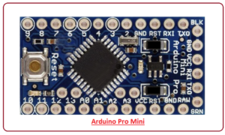](https://www.theengineeringprojects.com/wp-content/uploads/2018/06/introduction-to-arduino-pro-mini-9.png)6- The labeling on the regulator defines the version of the board i.e. KB33 represents 3.3V edition and KB50 represents 5V edition. However, the board version can also be indicated by measuring the voltage between Vcc and GND pin.

7- This board doesn’t come with built-in connectors that give you the flexibility to solder the connector in any way you can, based on the requirements and space available for your project.

8- Like other Arduino boards, Arduino Pro Mini is open source i.e. you can modify and use the board according to your requirements as all the data and support related to this board is readily available.

9- Overcurrent protection ability is another feature that makes this device safe to use in the applications where passing current can affect the overall performance of the project.

10- It comes with a flash memory of 32KB out of which 0.5 is used for a bootloader. The flash memory is used for storing the code of the board. It is a non-volatile memory and stores information even if the connection with voltage supply is lost.

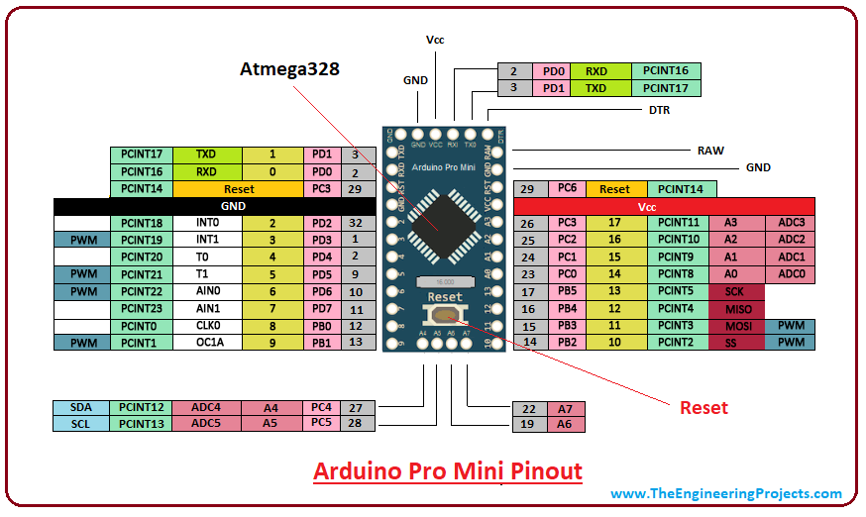

**PIN DESCRIPTIONS:-**

Each pin on the Pro Mini board comes with a specific function associated with the board.

**GND.** There are more than one ground pins incorporated on the board which can be used as per requirement when more ground pins are needed for the project.

[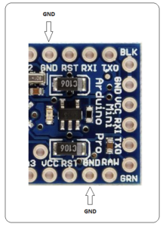](https://www.theengineeringprojects.com/wp-content/uploads/2018/06/introduction-to-arduino-pro-mini-3.png)

[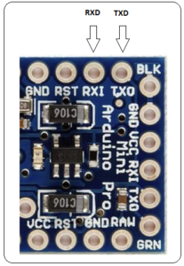](https://www.theengineeringprojects.com/wp-content/uploads/2018/06/introduction-to-arduino-pro-mini-6.png)

**TXD&RXD -**These pins are used for serial communication. TXD represents the transmission of serial data. RXD is used for receiving the data.

**AIN0 and AIN1 -** These pins are connected to the internal comparator.

**VCC-** It represents the regulated voltage which can be regulated to either 5V or 3.3V based on the version of the board.

[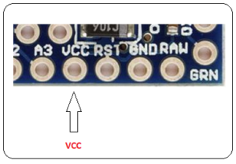](https://www.theengineeringprojects.com/wp-content/uploads/2018/06/introduction-to-arduino-pro-mini-4.png)

**RAW-** This pin is used for supplying raw voltage to the board. It is connected to unregulated power supply ranges from 5V to 12 V.

[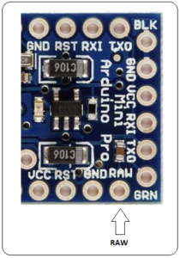](https://www.theengineeringprojects.com/wp-content/uploads/2018/06/introduction-to-arduino-pro-mini-7.png)

**PWM-**   There are 6 digital pins labeled as 3,5,6,9,10, and 11 available on the board that provide PWM (pulse width modulation). This process is used for producing analog results with digital resources.

**RESET-**   The Pro Mini board comes with a reset pin which comes handy where board hangs up in the middle of the running program. Making this pin LOW will reset the board.

[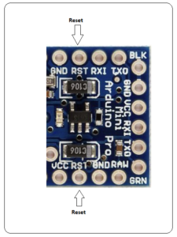](https://www.theengineeringprojects.com/wp-content/uploads/2018/06/introduction-to-arduino-pro-mini-5.png)

**Programming Header-**  FTDI six-pin the board header is connected on these pins which is used to program

[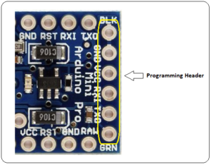](https://www.theengineeringprojects.com/wp-content/uploads/2018/06/introduction-to-arduino-pro-mini-8.png)

**SPI-** It represents Serial Peripheral Interface which is mainly used for the transmission of data between microcontrollers and other peripherals like sensors and registers. Four pins 10(SS), 11(MOSI), 12(MISO), and 13(SCK) are used for this purpose.

**Analog Pins-** There are 8 analog pins available on the board labeled as A0 to A7. These pins are used to input analog signals and they come with a total resolution of 10bit.

**External Interrupts -**There are two external interrupts available called T0 and T1. They are also known as hardware interrupts.

**I2C-**  A4 and A5 are used for developing I2C communication. A4 is known as serial data line (SDA) which holds the data and A5 shows serial clock line (SCL) which provides data synchronization between the devices.

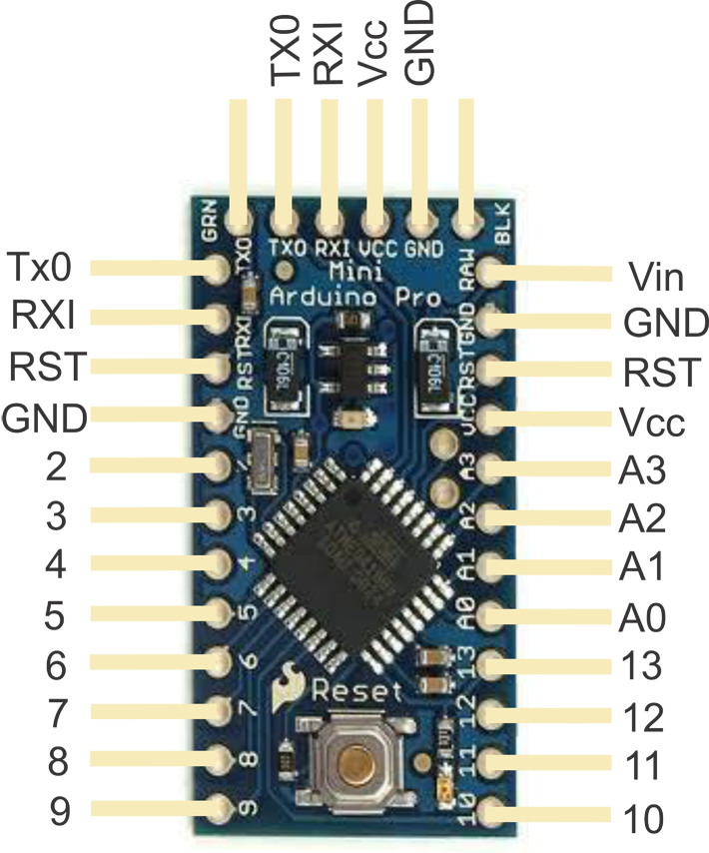

**9 VOLTS BATTERY SOURCE**

The **nine-volt battery**, or **9-volt battery**, is a common size of battery that was introduced for the early [transistor radios](https://en.wikipedia.org/wiki/Transistor_radio). It has a rectangular prism shape with rounded edges and a polarized snap connector at the top. This type is commonly used in [walkie-talkies](https://en.wikipedia.org/wiki/Walkie-talkie), [clocks](https://en.wikipedia.org/wiki/Clock) and [smoke detectors](https://en.wikipedia.org/wiki/Smoke_detector). The board can operate on an external supply of 6 to 20 volts. If supplied with less than 7V, however, the 5V pin may supply less than five volts and the board may be unstable.

If using more than 12V, the voltage regulator may overheat and damage the board.

The recommended range is 7 to 12 volts.

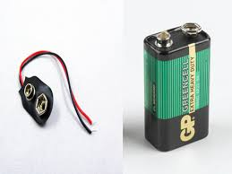

**LAPTOP COMPUTERS**

A **laptop**, also called a **notebook computer** or simply a **notebook**, is a small, portable [personal computer](https://en.wikipedia.org/wiki/Personal_computer) with a "[clamshell](https://en.wikipedia.org/wiki/Flip_(form))" form factor, having, typically, a thin [LCD](https://en.wikipedia.org/wiki/Liquid-crystal_display) or [LED](https://en.wikipedia.org/wiki/Light-emitting_diode) [computer screen](https://en.wikipedia.org/wiki/Computer_screen) mounted on the inside of the upper lid of the "[clamshell](https://en.wikipedia.org/wiki/Clamshell_design)" and an [alphanumeric keyboard](https://en.wikipedia.org/wiki/Alphanumeric_keyboard) on the inside of the lower lid. The "clamshell" is opened up to use the computer. Laptops are folded shut for transportation, and thus are suitable for [mobile use](https://en.wikipedia.org/wiki/Mobile_computing).[[1]](https://en.wikipedia.org/wiki/Laptop#cite_note-wikipedia-1) Its name comes from "[lap](https://en.wikipedia.org/wiki/Lap)", as it was deemed to be placed for use on a person's lap. Although originally there was a distinction between laptops and notebooks, the former being bigger and heavier than the latter, as of 2014, there is often no longer any difference.[[2]](https://en.wikipedia.org/wiki/Laptop#cite_note-HowStuffWorks-2) Laptops are commonly used in a variety of settings, such as at work, in education, in playing games, Internet surfing, for personal multimedia and general home computer use.

Laptops combine the components, inputs, outputs, and capabilities of a [desktop computer](https://en.wikipedia.org/wiki/Desktop_computer), including the [display screen](https://en.wikipedia.org/wiki/Computer_monitor), small [speakers](https://en.wikipedia.org/wiki/Computer_speakers), a [keyboard](https://en.wikipedia.org/wiki/Computer_keyboard), [hard disk drive](https://en.wikipedia.org/wiki/Hard_disk_drive), [optical disc drive](https://en.wikipedia.org/wiki/Optical_disc_drive), pointing devices (such as a [touchpad](https://en.wikipedia.org/wiki/Touchpad) or trackpad), a [processor](https://en.wikipedia.org/wiki/Processor_(computing)), and [memory](https://en.wikipedia.org/wiki/Computer_memory) into a single unit. Most modern laptops feature integrated [webcams](https://en.wikipedia.org/wiki/Webcam) and built-in [microphones](https://en.wikipedia.org/wiki/Microphone), while many also have [touchscreens](https://en.wikipedia.org/wiki/Touchscreen). Laptops can be powered either from an internal [battery](https://en.wikipedia.org/wiki/Battery_(electricity)) or by an external [power supply](https://en.wikipedia.org/wiki/Mains_electricity) from an [AC adapter](https://en.wikipedia.org/wiki/AC_adapter). Hardware specifications, such as the processor speed and memory capacity, significantly vary between different types, makes, models and [price points](https://en.wikipedia.org/wiki/Price_point).

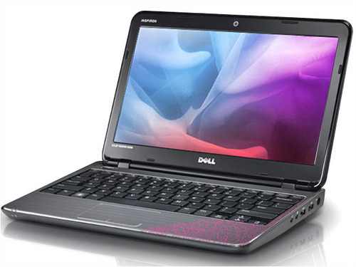

**LED LIGHT SOURCE**

A light-emitting diode (LED) is a two-lead semiconductor light source. It is a p–n junction diode that emits light when activated.

Light-Emitting Diodes (LED) are light sources utilizing diodes that emit light when connected in a circuit. The effect is a form of electro luminescence where LEDs release a large number of photons outward; the LED is housed in a plastic bulb, which concentrates the light source. The most important part of an LED is the semi-conductor chip located in the centre

of the light source. It consists of p and n regions with a junction between them. The p region is dominated by positive electric charges and the n region is dominated by negative electric charges. The junction is a kind of wall between the two regions, blocking the passage of charge carriers between the two regions.

When sufficient voltage is applied to the semi-conductor chip, electrons can move easily across the junction where they are immediately attracted to the positive forces in the p region. When an electron moves sufficiently close to a positive charge in the p region, the two charges “re-combine”

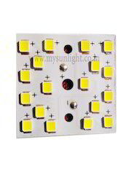

**SOLAR PANEL**

Solar panels absorb [sunlight](https://en.wikipedia.org/wiki/Sunlight) as a source of energy to generate [electricity](https://en.wikipedia.org/wiki/Electricity).

A [photovoltaic](https://en.wikipedia.org/wiki/Photovoltaic) (PV) module is a packaged, connected assembly of typically 6x10 photovoltaic [solar cells](https://en.wikipedia.org/wiki/Solar_cell).

Photovoltaic modules constitute the photovoltaic array of a [photovoltaic system](https://en.wikipedia.org/wiki/Photovoltaic_system) that generates and supplies [solar electricity](https://en.wikipedia.org/wiki/Solar_electricity) in commercial and residential applications.

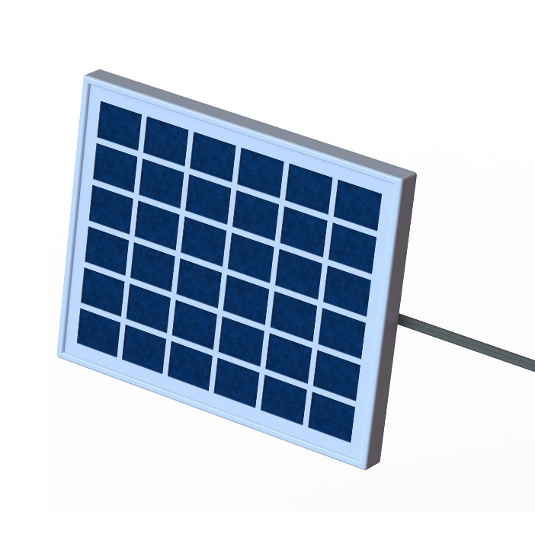

**Photovoltaic solar**

**Panels** absorb [sun light](https://en.wikipedia.org/wiki/Sunlight) as a source of energy to generate [electricity](https://en.wikipedia.org/wiki/Electricity). A [photovoltaic](https://en.wikipedia.org/wiki/Photovoltaic) (PV) module is a packaged, connected assembly of typically 6x10 photovoltaic [solar cells](https://en.wikipedia.org/wiki/Solar_cell). Photovoltaic modules constitute the photovoltaic array of a [photovoltaic system](https://en.wikipedia.org/wiki/Photovoltaic_system) that generates and supplies [solar electricity](https://en.wikipedia.org/wiki/Solar_electricity) in commercial and residential applications.

Each module is rated by its [DC](https://en.wikipedia.org/wiki/Direct_current) output power under standard test conditions (STC), and typically ranges from 100 to 365 [Watts (W)](https://en.wikipedia.org/wiki/Watt). The [efficiency](https://en.wikipedia.org/wiki/Solar_cell_efficiency) of a module determines the area of a module given the same rated output – an 8% efficient 230 W module will have twice the area of a 16% efficient 230 W module. There are a few commercially available solar modules that exceed efficiency of 24%.

**BREAD BOARD**

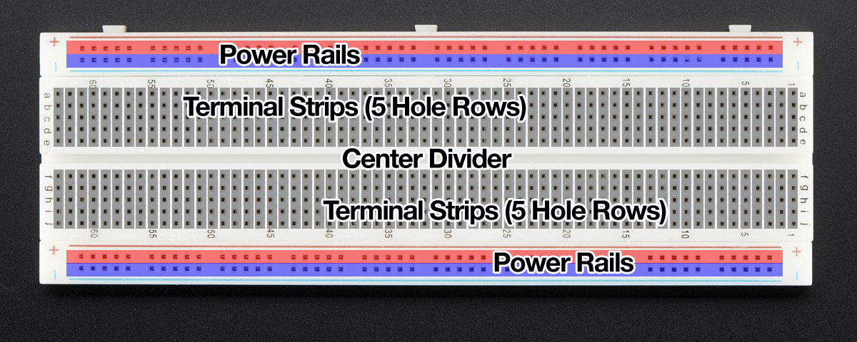

A **breadboard** is a construction base for [prototyping](https://en.wikipedia.org/wiki/Prototype) of [electronics](https://en.wikipedia.org/wiki/Electronic_circuit). Originally it was literally a bread board, a polished piece of wood used for slicing bread. In the 1970s the **solderless breadboard** (a.k.a. **plug board**, a terminal array board) became available and nowadays the term "breadboard" is commonly used to refer to these.

Because the solderless breadboard does not require [soldering](https://en.wikipedia.org/wiki/Soldering), it is reusable. This makes it easy to use for creating temporary prototypes and experimenting with circuit design. For this reason, solderless breadboards are also popular with students and in technological education. Older breadboard types did not have this property. A [stripboard](https://en.wikipedia.org/wiki/Stripboard) ([Vero board](https://en.wikipedia.org/wiki/Veroboard)) and similar prototyping [printed circuit boards](https://en.wikipedia.org/wiki/Printed_circuit_board), which are used to build semi-permanent soldered prototypes or one-offs, cannot easily be reused. A variety of electronic systems may be prototyped by using breadboards, from small analog and digital circuits to complete [central processing units](https://en.wikipedia.org/wiki/Central_processing_unit) (CPUs).

**These "solder-less" breadboards are incredibly handy for building circuits. They are durable and reusable and have tons of work space. They not only hold the parts steady, a breadboard also has internal wiring to make connections fast.**

**16x2 LCD SCREEN**

The Liquid Crystal library allows user to control LCD displays that are compatible with the Hitachi HD44780 driver.

The LCDs have a parallel interface, means microcontroller has to manipulate several interface pins at once to control the display.

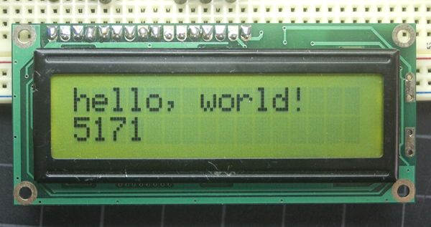

The interface consists of the following pins:

* A **register select (RS) pin** that controls where in the LCD's memory you're writing data to. You can select either the data register, which holds what goes on the screen, or an instruction register, which is where the LCD's controller looks for instructions on what to do next.
* A **Read/Write (R/W) pin** that selects reading mode or writing mode
* An **Enable pin** that enables writing to the registers(high or low) are the bits that you're writing to a register when you write, or the values you're reading when you read.
* There's also a **display contrast pin (Vo)**, **power supply pins (+5V and GND)** and **LED Backlight** pins that you can use to power the LCD, control the display contrast, and turn on and off the LED backlight, respectively. The process of controlling the display involves putting the data that form the image of what you want to display into the data registers, then putting instructions in the instruction register.

**IC-7905CT Voltage Regulator**

The voltage source in a circuit may have fluctuations and would not give the fixed voltage output. The voltage regulator IC maintains the output voltage at a constant value.

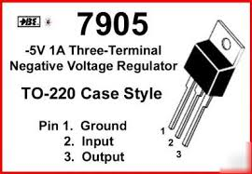

7905 provides a regulated supply of -5 V and 1A current. Its additional features include internal thermal overload protection, short circuit protection and output transistor safe operating area compensation.

**Specifications**

* Output Type: Fixed
* Output Voltage: -5V dc
* Current Output: up to 1.5A
* Input Voltage: -7.5 to -25VDC
* Line Regulation: 100 mV
* Load Regulation: 100 mV
* Dropout Voltage (Max): 1.4 V @ 1A
* Category: Linear Voltage Regulators - Standard
* Polarity: Negative
* Operating Temperature: 0 to +125°C
* Mounting Style: Through Hole
* Pin Spacing Pitch: 2.54mm
* Hole Diameter: 3.8mm
* Dimensions: 10.4 x 4.6 x 9.15mm

**POTENTIOMETER**

A potentiomete**r** is a three-terminal resister with a sliding or rotating contact that forms an adjustable voltage divider.If only two terminals are used, one end and the wiper, it acts as a variable resistor or rheostat.

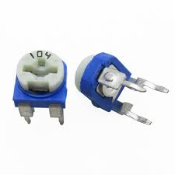

### Applications

* Voltage and Current Control Circuits
* Used as volume control knobs in radios
* Tuning or controlling circuits
* Analog input control knobs

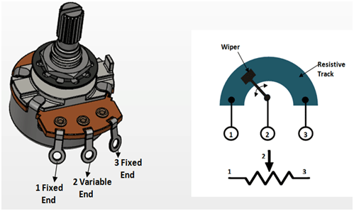**PIN DIAGRAM –**

ZERO PCB PLATE

As its name suggests, **general purpose PCB’s** are widely used to embed circuits randomly for running of hardware. Its layer is coated with copper and allows proper soldering without any short circuit.

**General purpose board**, connections are not built so connections are to be created. Small projects and models are composed for estimating its successful outcomes and therefore through its analysis industry based projects are formed and utilized in commercial sector and day to day activities accordingly.

For preparing electronics projects, it’s the best option. Now days soldering machines are available for embedding the components and accessories automatically through automation. Its huge demand is used in manufacturing large machineries and high technology projects. **Buy online general purpose zero PCB** with reasonable charges.

 We deal with few PCB’s at stores which comprise multipurpose PCB board 12x18cm, 30x15cm, 6x8cm, 8x12cm and 10x10cm. **Buy online multipurpose PCB boards** and enjoy **online PCB design** at affordable charges.

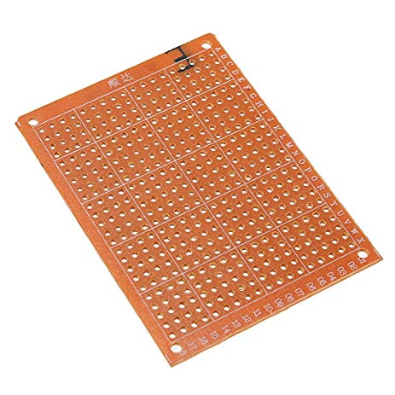

CONNECTING WIRES

Connecting wires allows an electrical current to travel from one point on a circuit to another because electricity needs a medium through which it can move. Most of the connecting wires are made up of copper or aluminum. Copper is cheap and good conductivity. Instead of the copper, we can also use silver which has high [**conductivity**](https://buddymantra.in/active-component-transistors/) but it is too costly to use.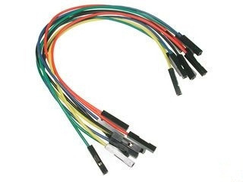

**TRANSMITTER SECTION**

**COMPONENTS USED:-**

1. **ARDUINO PRO MINI DEVELOPMENT BOARD**
2. **LAPTOP COMPUTERS**
3. **LED LIGHT SOURCE**
4. **ZERO PCB PLATE**
5. **CONNECTING WIRES**
6. **POLYMER SHEET**

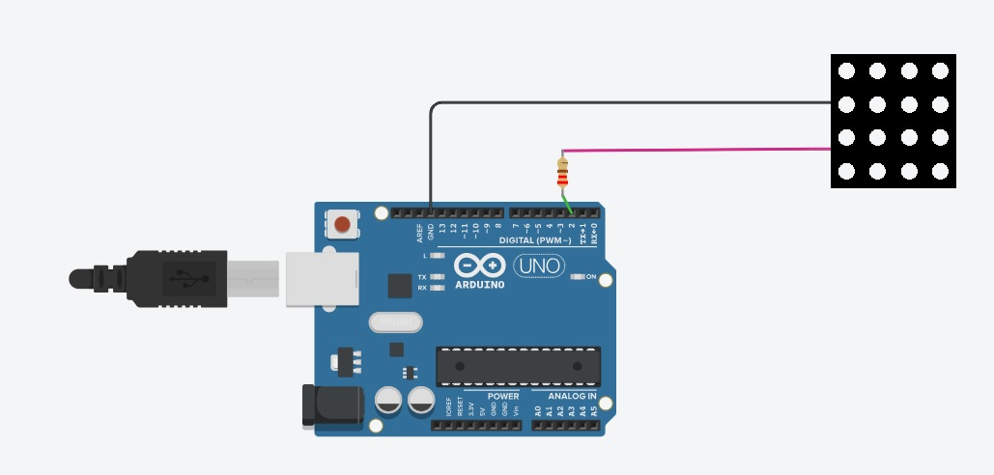**CIRCUIT DIAGRAM:-**

**WORKING PROCESS:-**

The transmitter circuit consists of the above configured elements.

The laptop provides the digital data to the Arduino UNO development board using connecting cord.

The Arduino UNO board only acts as a Digital to Analog converter and is programmed to convert received digital data from the laptop into analog signal.

This Signal is then fed to the LED Optical source which emit the signal in the form of short burst of light.

For this our LED must have high ON-OFF switching capability.

Hence we can say that our data is transmitted using Amplitude Modulation or ON-OFF Keying.

**RECEIVER SECTION**

**COMPONENTS USED:-**

**1) ARDUINO PRO MINI DEVELOPMENT BOARD**

**2) LAPTOP COMPUTERS**

**3) SOLAR PANEL**

**4) 9V DC BATTERY**

**5) 16*4 LCD SCREEN**

**6) BREAD BOARD**

**7) IC-7905 CT VOLTAGE REGULATOR**

**8) POTENTIOMETER**

**9) CONNECTING WIRES**

**10) POLYMER SHEET**

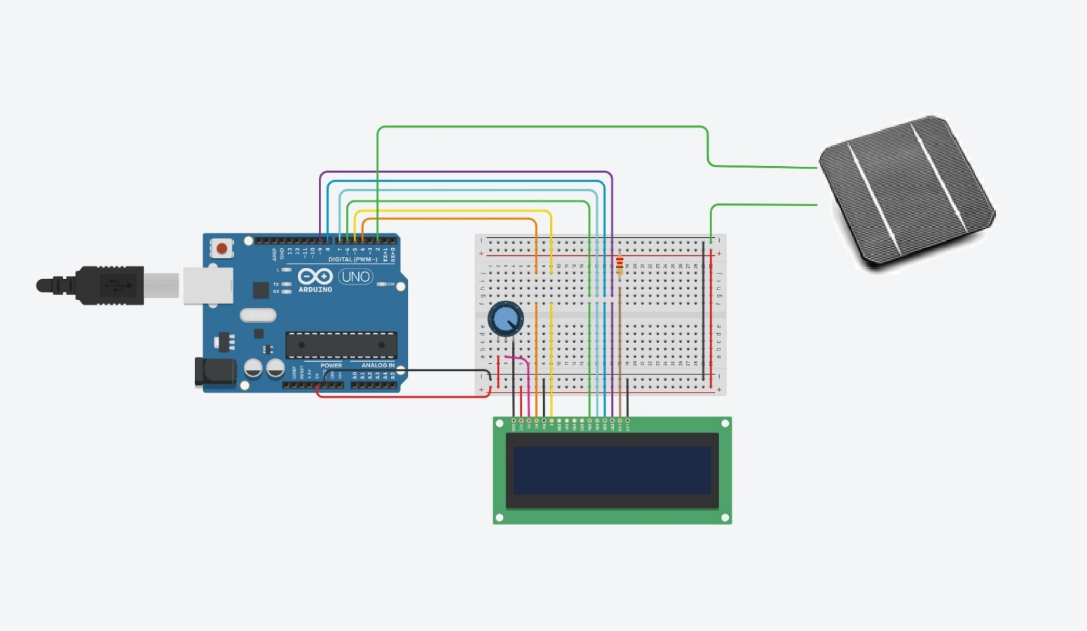**CIRCUIT DIAGRAM:-**

**WORKING PROCESS:-**

The receiver circuit consists of a solar panel which receives the optical signal through the LED light source.

This amplitude modulated signal is then converted to equivalent electrical signal by the solar panel and is again fed to Arduino UNO which converts the Analog electrical signal into digital form.

This digital data is inputted to the Laptop computer using connecting cords and we receive our transmitted data.

Thus our complete circuit transmit data wirelessly.

**COST ESTIMATION**

|  |  |  |  |
| --- | --- | --- | --- |
| **S.NO.** | **COMPONENT USED** | **QUANTITY** | **PRICE/UNIT (₹)** |
| 01) | Arduino Pro Mini Development Board | 2 UNITS | 400 |
| 02) | 9 Volt dc Battery(one piece) | 1 UNIT | 30 |
| 03) | LED Light Source | 1 UNIT | 40 |
| 04) | Solar Panel | 1 UNIT | 300 |
| 05) | Bread Board | 1 UNIT | 90 |
| 06) | 16X2 LCD Screen | 1 UNIT | 300 |
| 07) | 5 Volt -1.2A Voltage Regulator(IC-7905 CT) | 1 UNIT | 10 |
| 08) | One 10K ohm Potentiometer | 1 UNIT | 5 |
| 09) | Zero PCB Plate | 1 UNIT | 5 |
| 10) | Connecting Wires | 5 UNITS | 20 |
| 11) | One Polymer Sheet | 1 UNIT | 50 |
|  |  |  | TOTAL = 1250 |

TRANSMITTER CODE:

int ledPin = 13;

char ch;

int asc;

int i = 0;

int j = 0;

int bin[7];

// bin[0]=x[7] or MSB and bin[7]=x[0] or LSB

void setup()

{

Serial.begin(9600);

pinMode(ledPin, OUTPUT);

for (i = 0; i < 7; i++)

bin[i] = 0;

}

void loop()

{

if (Serial.available() > 0) {

ch = Serial.read();

asc = int(ch);

Serial.println(asc);

for (i = 0; i < 7; i++) {

bin[i] = asc % 2;

asc = asc / 2;

Serial.println(bin[i]);

}

for (i = 0; i < 7; i++) {

if (bin[i] == 0) {

for (j = 0; j < 2; j++) {

digitalWrite(ledPin, HIGH);

delay(5);

digitalWrite(ledPin, LOW);

delay(5);

}

delay(40);

}

else if (bin[i] == 1) {

for (j = 0; j < 5; j++) {

digitalWrite(ledPin, HIGH);

delay(5);

digitalWrite(ledPin, LOW);

delay(5);

}

delay(10);

}

}

}

}

RECEIVER CODE:

#include <LiquidCrystal.h>

LiquidCrystal lcd(12, 11, 6, 5, 4, 3); //RS,EN,D4,D5,D6,D7

int pin = 2;

volatile unsigned int pulse;

char ch;

int i = 0;

int j = 0;

int bin[7];

double asc = 0;

void setup()

{

//Serial.begin(9600);

pinMode(pin, INPUT);

attachInterrupt(0, count_pulse, RISING); // pulse is int storing the amount of rising LED //flashes from the transmitter

lcd.begin(16, 2);//initializing LCD

for (i = 0; i < 5; i++) {

lcd.setCursor(0, 0);

lcd.print("WELCOME TO BTKIT");

lcd.setCursor(0, 1);

lcd.print(" LIFI PROJECT");

lcd.noDisplay();

delay(250);

lcd.display();

delay(300);

}

lcd.clear();

lcd.setCursor(0, 0);

lcd.print(" TYPE YOUR TEXT");

lcd.setCursor(0, 1);}

void loop(){

if (pulse != 0){

interrupts();

delay(60);

i = 0;

if (pulse < 3){

bin[i] = 0;

i++;}

else if (pulse > 3){

bin[i] = 1;

i++;}

if (i > 7) {

for (j = 0; j < 7; j++) {

asc = asc + (bin[j] * pow(2, 7 - j)); }

i = 0; }

Serial.println(char(asc));

if (char(asc) == "-") {

Serial.print(" CLEAR LCD");

lcd.clear();

lcd.setCursor(0, 0);

lcd.print(" TYPE YOUR TEXT");

lcd.setCursor(0, 1);

}

lcd.print(char(asc));

}}

void count_pulse()

{

pulse++;

}

**FUTURE SCOPE**

In the data transmission prototype, the encoding and decoding can be used in the transmitter part and receiver part to reduce the error in transmission. In addition, the data transmission rate could be enhanced by using fast switching multiple LED’s. The tests were carried out indoors under ambient light conditions. Larger coverage of area for transmission can be obtained by using LED arrays.

Li Fi is a fast and cheap wireless-communication system. The increasing demand for higher bandwidths, faster and more secure data transmission as well as environmental and undoubtedly human friendly technology heralds the start of a major shift in wireless technology, a shift from RF to optical wireless technologies. The possibilities are numerous and research can provide us with many solutions. This technology can be used to make every LED bulb into a Li-Fi hotspot to transmit data wirelessly and will proceed to give us a safer, faster and a greener network.

In India with the growing population (1.252 billion) and number of internet users (402 million) in India, we are definitely running out of space. By 2019, it is estimated that the world will be exchanging roughly 35 quintillion bytes of information each month. Since, radio frequencies are already in use and heavily regulated, that data is going to struggle to find a spot in line. Given the situation, Li-Fi will be crucial for India. Li-Fi is till in its nascent stage but the scope for it is limitless.

**CONCLUSION**

Light is inherently safe and can be used in places where radio frequency communication is often deemed problematic, such as in aircraft cabins or hospitals. So visible light communication not only has the potential to solve the problem of lack of spectrum space, but can also enable novel application. The visible light spectrum is unused, it's not regulated, and can be used for communication at very high speeds.

**BIBLIOGRAPHY**

* Watts, Michael (31 January 2012). "Meet Li-Fi, the LED-based alternative to household Wi-Fi". Wired Magazine.
* Gurpinder Singh, “Li-Fi (Light Fidelity) - An Overview to future Wireless technology in Field of Data Communication”, November (2015).
* Harald Haas. ["Harald Haas: Wireless data from every light bulb"](http://www.ted.com/talks/harald_haas_wireless_data_from_every_light_bulb). *ted.com*. [Archived](https://web.archive.org/web/20170608024336/https:/www.ted.com/talks/harald_haas_wireless_data_from_every_light_bulb) from the original on 8 June 2017.
* Wikipedia.com